State of Utah 110(a)(2) SIP Infrastructure Elements for Ozone

Section 110(a)(2)(D)(i)(I): Interstate Transport Provisions Prong II: Interfere with Maintenance

Summary
"Each such plan shall … contain adequate provisions: prohibiting, consistent with the provisions of this subchapter, any source or other type of emissions activity within the state from emitting any air pollutant in amounts which will … interfere with maintenance by, any other state with respect to any such national primary or secondary ambient air quality standard, or interfere with measures required to be included in the applicable implementation plan for any other state under part C of this subchapter to prevent significant deterioration of air quality to protect visibility.”

Introduction
The Utah Division of Air Quality (DAQ) submitted Utah SIP Section 11o(a)(2)(D)(i)(I) Interstate Transport Provisions SIP to the Environmental Protection Agency (EPA) on January 31, 2013. Based on EPA Assistant Administrator Gina McCarthy’s guidance memorandum titled Next Steps for Pending Redesignation Requests and State Implementation Plan Actions Affected by the Recent Court Decision Vacating the 2011 Cross-State Air Pollution Rule, issued on November 19, 2012, DAQ did not address the good neighbor obligation of Section 11o(a)(2)(D)(i)(I), commonly referred to as Prong 2 in their January 2013 submission.
On April 29, 2014, the U.S. Supreme Court reversed a D.C. Circuit decision, holding that the Clean Air Act (CAA) clearly states that States must address Prong 2 of the CAA Section 11o(a)(2)(D)(i)(I) within three years of any new or revised NAAQS promulgation. In response, EPA issued the memorandum Information on the Interstate Transport “Good Neighbor” Provision for the 2008 Ozone National Ambient Air Quality Standard (NAAQS) under Clean Air Act (CAA) Section 110(a)(2)(D)(i), on January 22, 2015.
On December 22, 2015 Utah submitted a supplement to address CAA section 110(a)(2)(D)(i)(I) with respect to the 2008 ozone NAAQS.
Utah’s SIP Section 11o(a)(2)(D)(i)(I) Prong 2 was disapproved on October 19, 2016. Utah DAQ has prepared this submittal to satisfy the requirements identified in EPA’s January 2015 memorandum and in response to the disapproval by the EPA in 81 FR 71991.

Good Neighbor Provisions
EPA has identified four steps for addressing transport of ozone, developed throughout several federal rulemakings, that establishes the Good Neighbor Provision (GNP) framework:
- Identify downwind air quality problems;
- Identify upwind States that contribute enough to those downwind air quality problems to warrant further review and analysis;
- Identify emission reductions necessary to prevent an identified upwind State from contributing significantly to those downwind air quality problems, and;
- Adopt permanent and enforceable measures needed to achieve those emission reductions.
DAQ applied the first to steps of the GNP framework to the State of Utah 2008 ozone transport and identified one downwind air quality problem. EPA has classified the Denver Non-attainment area as moderate under the 2008 8-hour ozone standards.
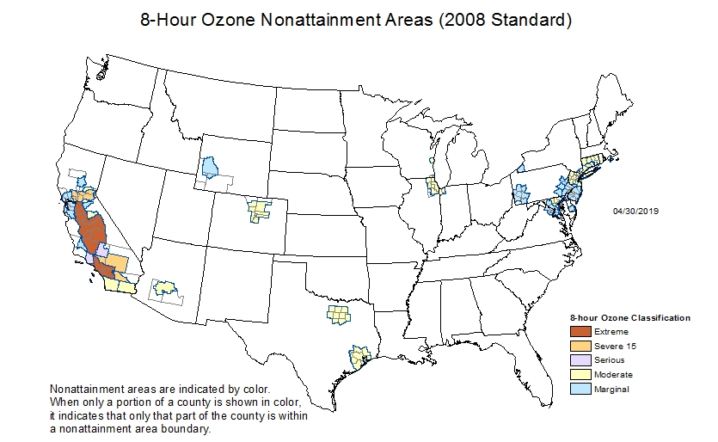
Modeling for the 2016 Cross-State Air Pollution Rule (CSAPR) Update indicates that Utah contributes to three Maintenance Receptor sites in Colorado (See Table 1) for the 2008 8-hour ozone standard.
Table 1 - Colorado Maintenance Receptor Sites
Monitor I.D. | State | County | Utah Modeled Contribution
80590006 | Colorado | Jefferson | 1.03 ppb
80590011 | Colorado | Jefferson | 1.17 ppb
80350004 | Colorado | Douglas | 1.63 ppb

Modeling

EPA Modeling
However, in 2017, EPA issued a memo that provided new contribution modeling outputs derived from nationwide photochemical modeling for 2023 to identify potential nonattainment or maintenance receptors under the 2008 ozone NAAQS. This update states that “no areas in the United States, outside of California, are expected to have problems attaining and maintaining the 2008 ozone NAAQS in 2023.” Under the updated modeling, all three monitors project 2023 “3x3” max values between 67.5 and 73.9 ppb. These three monitors, as well as every other Colorado monitors, achieve values below the 75 ppb threshold established in the 2008 ozone standards. Under the updated EPA modeling, Utah does not contribute to any downwind air quality problem under the 2008 ozone standards. Therefore, Utah is not required to complete steps 3 or 4 of the GNP.

Colorado Modeling
On July 3, 2018, EPA approved Colorado’s 2008 8-hour ozone NAAQS attainment demonstration for the Denver Metro/North Front Range Nonattainment Area, which included a demonstration that, were it not for atypical activities, the three Maintenance Receptor sites identified in Table 1 will not be a “maintenance” receptor for the 2017 modeling year. Colorado conducted modeling that removed activity-influenced values caused by events such as stratospheric intrusions or wildfires, showing that these maintenance receptors would have had maximum design values below the 2008 NAAQS. In the approval, EPA states: “The factual and legal background for this action is discussed in detail in our April 6, 2018 proposed approval. 83 FR 14807. The proposal provides a detailed description of the revisions and the rationale for the EPA’s proposed actions.” (83 FR 31068). In their proposed approval EPA states that their rationale for approving the SIP as follows: “Colorado also evaluated high ozone days from 2009 to 2013 that were likely influenced by atypical activities such as wildfire or stratospheric intrusion, but were included in the calculation of the 2011 baseline ozone design value (see Table 3; CDPHE, 2016d 28). While Colorado did not submit formal demonstrations under the Exceptional Events Rule (40 CFR 50.14) for these days because they do not affect the attainment status, which is evaluated based on 2015–2017 monitoring data, these days do affect the baseline design value and thus affect the model projected future design value for 2017. Table 4 shows the revised 2011 baseline design value when the data likely influenced by atypical activities are excluded, and Table 4 also shows the results of the model attainment demonstration using both the 3x3 and 7x7 matrices for calculating the model RRF. All future design values are below the 75 ppb NAAQS using both approaches when data possibly influenced by atypical activities are excluded in the calculation of the 2011 design values. The EPA concurs with Colorado’s assessment that the model was properly configured, met EPA performance requirements, and was appropriately used in its application. The EPA finds that the WOE [weight-of-evidence] analysis supports a determination that the area will attain the 75 ppb ozone NAAQS by 2017.” (83 FR 14807).
Based on Colorado’s SIP, and EPA’s subsequent approval, all future design values are below the 2008 8-hour ozone NAAQS at the maintenance receptors identified in Table 1. Therefore, it would be appropriate to consider these sites to be attainment receptors, rather than maintenance receptors. Therefore, according to modeling conducted by the State of Colorado emissions from Utah would not be contributing to nonattainment or interfering with maintenance at the two monitors in Jefferson County and the monitor in Douglas County, Colorado.

Utah Emission Reductions
Regardless, Utah has enacted and benefitted from multiple actions that have contributed to overall reductions of NO_{x} and VOC’s from the inventory. Listed below is a summarization of actions taken since the previous filing:
- Utah Water Heater Rule: Water heaters are a significant source of NOx emissions from area sources. As of July 1, 2018, all new water heaters statewide must be ultra-low NOx. The rule is projected to reduce area-source emissions of NOx by 35 percent by 2024.

- Utah Area Source Rules: Utah promulgated 13 coating and 2 degreasing rules to reduce VOC’s. These rules address the vast majority of Utah’s area source VOC inventory. The remaining area source VOC inventory categories are insignificant sources. Utah also promulgated 2 combustion rules that reduce both VOC’s and NOx.

- Federal Tier 3 Motor Vehicle Emission and Fuel Standards: As the federal tier 3 vehicle and fuel standards are implemented throughout the country, Utah is observing benefits comparable to the national trends. DAQ anticipates continual reduction in tailpipe emissions of VOC and NO_{x} as the vehicle inventory in Utah continues to cycle Tier 3 compliant vehicles in and older vehicles out.
Additionally, the Utah Governor worked closely with the state legislature and local refineries to negotiate Tier 3 fuel production from local refineries that would otherwise be exempted from the Tier 3 production standards. Tier 3 fuel reduces sulfur content from 30 to 10 parts per million (PPM). The availability of Tier 3 fuel in the Utah market enables an anticipated reduction of VOC and NOx emissions from non-Tier 3 compliant vehicles by increasing the efficiency of existing catalyst systems. When this fuel standard is combined with the Tier 3 vehicles described above, VOC and NO_{x} emissions are anticipated to be reduced by 80 percent.
- Power Generation Units: On April 15, 2015, the Carbon Power Plant near Helper Utah permanently ceased operations. This source was Utah’s oldest operating coal power plant, which operated two units and produced 172-megawatts. Carbon Power Plant will not be operational again due to two factors, a Regional Haze SIP requirement passed in 2015 that required its permanent shutdown, and the dismantling of both units.
Additionally, a second power generation unit has ceased operations. Utah Power Plant, located in Magna Utah, announced the shuttering of their 1.5 million megawatt power plant on May 1, 2019. This dual fuel power plant closure has an anticipated emission reduction of 6,000 tons. This includes a substantial reduction of both NO_{x} and VOC’s. It is anticipated the 1.5 million megawatt hours of electricity will be replaced with Green e-certified renewable energy certificates, preventing additional creation of NO_{x} or VOC production from elsewhere in the grid.
Finally, Intermountain Power Plant (IPP) is a 1,900 Megawatt coal-fired power plant near Delta Utah. This power generation facility is operated by the Los Angeles Department of Water and Power. Since the power purchased from this facility is sold and distributed throughout the state of California, IPP is subject to California regulation and must adhere to the Greenhouse Gases Emission Performance Standard for Baseload Electrical Generating Resources listed in California Public Utilities Code. These rules require any source providing power to California to comply with the greenhouse gases emission performance standard established by the California Public Utilities Commission. Therefore, to continue supplying California with it power, IPP will be required to retrofit its generation units for natural gas by 2025, or risk being shuttered. DAQ anticipates a substantial reduction in NO_{x} and VOC emissions from IPP regardless of the outcome.

Conclusion

Based on evidence provided through EPA guidance and modeling, along with permanent emission reductions through state and federal regulation, DAQ has determined the State of Utah is in compliance with the requirements of CAA Section 110(a)(2)(D)(i)(I) Prong 2. An analysis of all facts presented throughout this submission clearly indicates Utah does not interfere with ozone maintenance receptors in any downwind state.

Cross-State Air Pollution Rule Update for the 2008 Ozone NAAQS. 81 FR 74504.
California Public Utilities Code, Division 4.1, Chapter 3.

